Flat Nylon Webbing
Flat nylon webbing is great for high abrasion applications, or for use with larger buckles with higher breaking strengths. It is ideally suited for leashes, collars, leads, ratchet straps, D-ring belts, etc. Flat nylon has a breaking strength of 3,500 lbs., so it works great for medium to heavy duty applications.

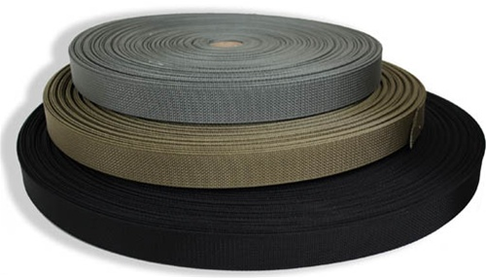
Figure 2.1: Flat Nylon Webbing

